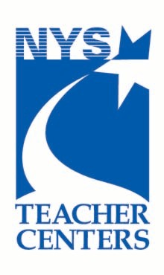
iPad Request Form

Eligibility: Members of Teacher Center of Broome County Consortium Schools who have attended the iPad Basics workshop are eligible to borrow iPads.
Completing this form does not guarantee the dates you requested.
You will receive an email confirmation if your request can be filled.

First name: Last name:
School district: School name:
Email:
Work phone: Cell phone:
When did you attend the iPad Basics workshop?:
How many would you like to borrow? (up to 10):
What date would you like your reservation to begin?
How many days are you requesting them for? If Other, state number
You can borrow them for up to 2 weeks. If no one else has requested them, it may be possible to renew them at the end of your loan period.

Save this form and email to: bctc@btboces.org

Please note that iPads must be picked up and returned to the Teacher Center
by the requester during Teacher Center hours, Mon-Thurs, 3:30-6:30

